**Course Methods Year 12 test three 2022**

Student name: ________________ Teacher name: ________________

**Task type: Response**

**Time allowed for this task: _____40______ mins**

**Number of questions: ____6_______**

**Materials required: Upto 3 calculators/classpads allowed**

Standard items: Pens (blue/black preferred), pencils (including coloured), sharpener, correction fluid/tape, eraser, ruler, highlighters

Special items: Drawing instruments, templates, **one page of A4 notes doublesided**

**Marks available: ___43___ marks**

**Task weighting: _10___%**

**Formula sheet provided: Yes**

**Note: All part questions worth more than 2 marks require working to obtain full marks.**

Q1 (3, 3 & 2 = 8 marks) (3.3.1)

Consider the discrete random variable  and the table of probabilities below.

|  |  |  |  |  |  |
| --- | --- | --- | --- | --- | --- |
|  | 0 | 1 | 2 | 3 | 4 |
|  | 0.2 |  | 0.3 |  | 0.25 |

1. Given that the expected value of  is 2.15, determine the values of .
2. Determine the standard deviation of to 3 dp, showing all reasoning.
3. Determine the  and Variance().

Q2 (3, 2, 1 & 3 = 9 marks) (3.3.3)

The number of  minutes late a train arrives at a particular station is a uniform probability distribution from 5 mins to 25 mins.

1. Sketch the probability density function for  showing all relevant features and labels.

Q2 continued

1. Determine the probability that the train will be less than 12 mins late given that it is at least 7 mins late.
2. Determine the mean number of minutes late.
3. Determine the standard deviation of  showing all reasoning.

Q3 (3, 3 & 2 = 8 marks) (3.3.1)

Consider a game where two ordinary dice are thrown into the air and then land and the sum of the two top numbers is added. If the sum is a prime number  etc then this is considered a win.

1. Determine the probability of a win. Show reasoning.
2. If this game was played 10 times, determine the probability that a win occurs at least 7 times. Show all reasoning.

Q3 cont-

1. Let  = sum of the top numbers of both dice. Determine the mean and standard deviation for .

Q4) (5 marks) (4.1.6)

Consider  where  are constants.

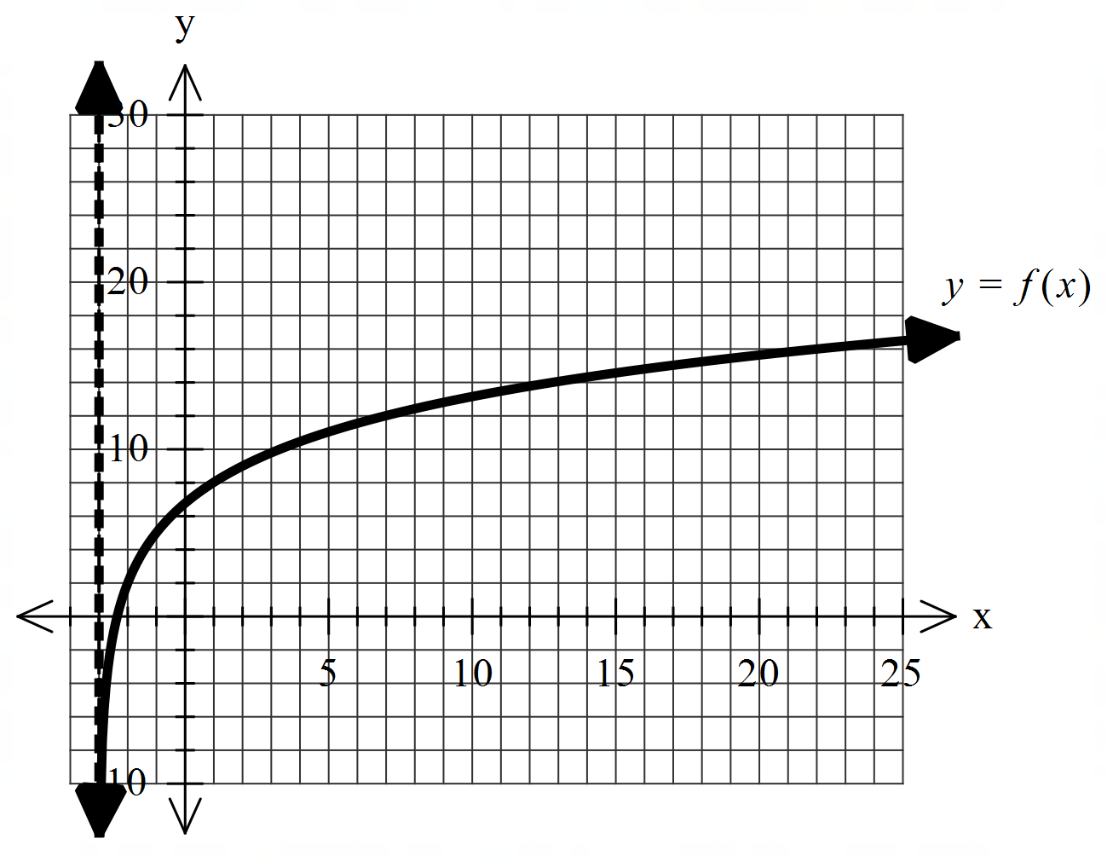

Using the graph above and given that the following points

 lie on the curve , determine the values of .

Q5 (2, 2 & 2 = 6 marks) (4.2.2)

Consider the probability density function  and zero for all other values

of .

1. Show that .
2. Determine the probability  for the above function.
3. Determine the median.

Q6 (2 & 5 = 7 marks) (4.1.11)

1. Show **without the use of a classpad** how to .

Continued on next page for Q6b

1. Using (a) above and **without the use of a classpad**, show how to evaluate .

Hint-use 

Q6 continued